**ASSIGNMENT – 6**

**Name – Ritvik Jindal**

**UID – 22BCS10235**

**CLASS – FL_IOT_604-A**

**108.**[**Convert Sorted Array to Binary Search Tree**](https://leetcode.com/problems/convert-sorted-array-to-binary-search-tree/description/)

/**

* Definition for a binary tree node.

* struct TreeNode {

* int val;

* TreeNode *left;

* TreeNode *right;

* TreeNode() : val(0), left(nullptr), right(nullptr) {}

* TreeNode(int x) : val(x), left(nullptr), right(nullptr) {}

* TreeNode(int x, TreeNode *left, TreeNode *right) : val(x), left(left), right(right) {}

* };

*/

class Solution {

public:

TreeNode* sortedArrayToBST(vector<int>& nums) {

nums.push_back(0);

TreeNode * res = sorting(nums,0,nums.size()-1);

return res;

}

TreeNode* sorting(vector<int> &nums,int low,int high){

TreeNode* res = new TreeNode();

if(low>=high){

return NULL;

}

int mid = low + (high-low)/2;

res->val = nums[mid];

res->left = sorting(nums,low,mid);

res->right= sorting(nums,mid+1,high);

return res;

}

};



**191.**[**Number of 1 Bits**](https://leetcode.com/problems/number-of-1-bits/description/)

class Solution {

public:

int hammingWeight(int n) {

int res=0;

while(n>0){

if(n & 1){

res++;

}

n = n>>1;

}

return res;

}

};



**912.**[**Sort an Array**](https://leetcode.com/problems/sort-an-array/description/)

class Solution {

public:

vector<int> sortArray(vector<int>& nums) {

mergesort(nums,0,nums.size()-1);

return nums;

}

void mergesort(vector<int> &vec,int low,int high){

if(low>=high){

return;

}

int mid = low + (high-low)/2;

mergesort(vec,low,mid);

mergesort(vec,mid+1,high);

merge(vec,low,high,mid);

}

void merge(vector<int> &arr,int low,int high,int mid){

int n1 = mid-low+1,n2 = high-mid;

vector<int> left(n1);

vector<int> right(n2);

for(int i =0;i<n1;i++){

left[i]=(arr[low+i]);

}

for(int i =0;i<n2;i++){

right[i]=(arr[mid+1+i]);

}

int i =0,j=0,k=low;

while(i<n1 && j<n2){

if(left[i]<=right[j]){

arr[k] = left[i];

i++;

}

else{

arr[k] = right[j];

j++;

}

k++;

}

while(i<n1){

arr[k++] = left[i++];

}

while(j<n2){

arr[k++] = right[j++];

}

}

};

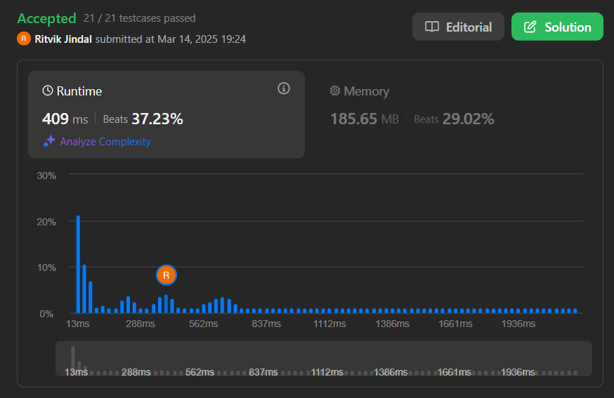

**53.**[**Maximum Subarray**](https://leetcode.com/problems/maximum-subarray/description/)

class Solution {

public:

int maxSubArray(vector<int>& nums) {

int res=nums[0],maxi = nums[0];

for(int i=1;i<nums.size();i++){

maxi = max(nums[i]+maxi,nums[i]);

res = max(res,maxi);

}

return res;

}

};



**932.**[**Beautiful Array**](https://leetcode.com/problems/beautiful-array/description/)

vector<int> beautifulArray(int N) {

vector<int> res = {1};

while (res.size() < N) {

vector<int> tmp;

for (int i : res) if (i * 2 - 1 <= N) tmp.push_back(i * 2 - 1);

for (int i : res) if (i * 2 <= N) tmp.push_back(i * 2);

res = tmp;

}

return res;

}



**372.**[**Super Pow**](https://leetcode.com/problems/super-pow/description/)

class Solution {

public:

int superPow(int a, vector<int>& b) {

long long pow = b[0];

int n=b.size();

if(n<1 || a==1){

return 1;

}

for(int i=1;i<n;i++){

pow *= 10;

pow += b[i];

pow %= 1140;

}

if(pow ==0){

pow = 1140;

}

return power(a,pow)%1337;

}

long long power(int &a,long long &pow){

if(pow==0){

return 1;

}

long long temp = pow/2;

long long hpow = power(a,temp);

if(pow%2==0){

return hpow*hpow%1337;

}

else{

return hpow*hpow*a %1337;

}

}

};

